

Year 7 Transition – ICT Task 1

Classification Systems

Learning Intention:

Success Criteria:

- Write a sentence explaining the difference between living and non-living.

Listed are different people who have created classification systems.

  - Aristotle
  - Andrea Cesalpino
  - John Ray
  - Augustus Quirinus Rivinus
  - Carl Linnaeus
  - Carl Woese
  - Thomas Cavalier-Smith


Search

Research how the different classification systems organise organisms.
Name of person who created classification system. | Classification System | How is it organised? | Could this system be used out in the field?



Investigate

What do living species all have in common?

- Explain what MR NGREWW is.

- Research 4 different animals and explain what 8 characteristics they have from MR NEGREWW.

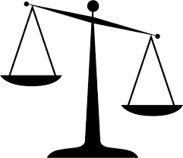
Evaluate

Create a classification key in the space below to classify the 4 animals that you researched.

Cite

Why must I cite my sources?
- I cannot claim the work or ideas of someone else as my own
- Plagiarism is not just when I directly copy words from someone else's work. Plagiarism is also when someone else's work is paraphrased or their ideas are used and claimed as my own
- Referencing has a positive effect and adds credibility to my work
- When I reference correctly, I am demonstrating that (a) I have read widely on the topic and (b) that I am supporting my hypotheses with comments from expert authors and/or reliable sources
- Correct referencing allows the marker/reader to follow-up my references and check the validity of my arguments for themselves.

Surname | Initial | Title of page | Full title of website | Date Written | Internet Address | Date of visit
Brown | J. | ‘Things in Space’ | Astronomy Facts | 1998 | http://www.astronomyfacts.com | 31 July 2019

